CHAPTER I
INTRODUCTION
Rationale of the Study
Today's technology helps improve how catfish farms manage their daily operations. Many farms still rely on handwritten records and manual spreadsheets to track feeding activities, feed usage, sales, and operational expenses. These traditional methods may lead to errors, lost records, and difficulty in reviewing past information. Because of this, farm owners may find it hard to clearly monitor their daily operations and evaluate the performance of the farm. In addition, manual recording makes it difficult to organize data and generate reports when needed. As farm operations continue to grow, the need for a more organized and reliable system becomes important to ensure accurate record-keeping and better farm management.
The LRS Hito Farm began operations in 2023 with four ponds that can accommodate a limited portion of hito. As the farm continues to operate, daily activities such as: (1) feeding, feed consumption recording, sales transactions, and expense tracking are still done manually using notebooks and spreadsheets. (2) Staff manually record feeding activities and feed usage, while customer orders for harvested hito are written in logbooks. (3) Analytics and Report is hard to monitor beacause of manual recoding (4) Feed inventory is also monitored through physical checking, (5) operational expenses such as feed, maintenance, and labor costs are calculated manually.Because of these manual processes, the farm experiences several challenges.
To address these problems, the Hito Farm Management System with Data Analytics is proposed for LRS Hito Farm. This web-based system helps record and monitor important farm activities. The system includes features such as Feeding Log, which records daily feeding activities and feed usage; Sales and Order Management, which records customer orders for harvested hito; Feed Inventory Monitoring, which tracks the available feed stock and automatically updates the inventory when feed is used; Analytics and Reports, which provide visual summaries and printable reports of farm operations; and Expense Tracking, which records operational expenses and calculates profit from recorded sales. Through this system, farm records can be organized digitally, making it easier for the owner and staff to review operations and manage the farm.
The Hito Farm Management System with Data Analytics aims to improve the management of LRS Hito Farm by providing a digital platform for recording and monitoring important farm operations. The system organizes records related to feeding activities, feed inventory, customer orders, sales transactions, operational expenses, and farm reports. Through the use of this system, the farm owner and staff can easily access organized data, generate reports, and monitor overall farm performance. It also helps reduce errors that may occur in manual recording and improves the accuracy of farm records. In addition, the system allows faster retrieval of information and better monitoring of daily farm activities. With these capabilities, the proposed system can support better decision-making and contribute to more organized, reliable, and effective farm management.

Objectives of the Study
General Objective
The study aims to design and develop a Hito Farm Management System with Data Analytics to be implemented at Poblacion, Esperanza, Sultan Kudarat, to enhance operations and monitor overall farm productivity.
Specific Objectives
- To monitor feeding and track feed consumption.
- To record customer orders for harvested hito and review past sales.
- To record and monitor feed inventory, including remaining stock levels and usage by staff.
- To provide visual analytics and printable reports summarizing overall operations, including feeding and inventory performance.
- To monitor operational expenses and calculate profits, including costs for feed, maintenance, and labor.
Scope and Limitation of the Study
Scope of the Study
The Hito Farm Management System with Data Analytics is designed to assist in managing and monitoring the daily operations. The system focuses on recording feeding activities, monitoring feed inventory, managing customer orders, tracking expenses, and generating analytical reports to support farm management and decision-making.
Feeding Log
Records the daily feeding activities of the hito. Each record includes the date, feed type, quantity used, and the staff member responsible for feeding. This helps to track feeding history and monitor feed usage.
Sales and Order Management
Records customer orders for harvested hito, including order date, quantity purchased, and total price. This helps the farm keep track of sales and review past orders.
Feed Inventory Monitoring
Monitors the available feed stock in the inventory. The system automatically updates the feed quantity whenever feeding activities are recorded, allowing to track feed usage and remaining stock.
Analytics and Reports
Visual charts and summaries of overall operations, with printable reports.
Expense Tracking
Allows users to monitor all operational expenses, including feed, maintenance, and labor costs, and automatically calculates profit from recorded sales.
Limitation of the Study
The system does not include hardware-based monitoring, such as IoT sensors for water quality, automated counting of fingerlings, or pond condition tracking. The study focuses on improving record-keeping, feeding management, sales tracking, and operational analytics within the farm.
Significance of the Study
The system has the potential to significantly benefit the business, owner and staff by improving the overall operation. Specifically, this study aims to benefit the following:
Owner
This system will help the farm owner monitor feeding activities, feed inventory, sales, and expenses in an organized way. It also provides reports and charts that help the owner review the farm operations and make better decisions.
Staff
This system will lessen the need for manual recording of feeding logs, feed inventory, sales, and expenses. It will help staff record and view information more easily, making their work more organized.
Researchers
This system will help the researchers apply their knowledge in developing a management system and improve their skills in system design, programming, and data management.
Future Researchers
This study can serve as a reference for future researchers who plan to develop similar systems related to farm management or aquaculture operations.

IPO Conceptual Framework
The IPO Conceptual Framework illustrates how the Hito Farm Management System with Data Analytics transforms raw operational data into actionable insights for farm management. Inputs such as feeding logs, harvested quantities, and staff records are processed through data validation, automated calculations, and reporting algorithms. The outputs include feeding reports, inventory summaries, and staff performance dashboards.
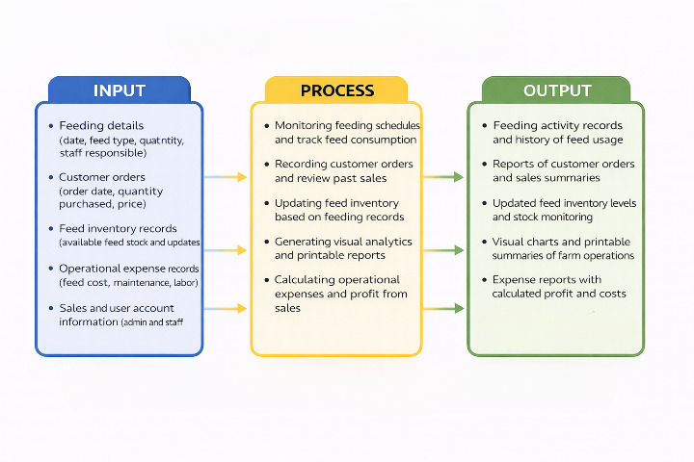
Definition of Terms
Feeding Log – A record of the daily feeding activities of the hito, including date, feed type, quantity, and staff responsible. It helps monitor feed usage and feeding patterns.
Sales and Order Management – Records customer orders for harvested hito, including order date, quantity, and total price, allowing the farm to track sales history.
Feed Inventory Monitoring – Tracks available feed stock. The system automatically updates the feed quantity whenever feeding is done, helping manage inventory efficiently.
Analytics and Reports – Visual charts and summaries of operations such as feeding, sales, and expenses. Reports can be printed for decision-making purposes.
Expense Tracking – Records operational expenses, including feed, labor, and maintenance costs. Profit is calculated automatically based on sales and expenses.
Profit – The difference between total sales and total operational expenses, showing the farm’s net earnings.
Staff Member – Any authorized user responsible for feeding, recording data, or managing operations in the system.
Order Quantity – The number of harvested hito requested by a customer in a sales order, used to track inventory and sales.
Feed Type – The kind of feed given to hito during feeding activities, recorded to monitor consumption and feeding patterns.

CHAPTER II
REVIEW RELATED LITERATURE

CHAPTER III
RESEARCH METHODOLOGY AND DESIGN
This chapter presents theories associated with obtaining necessary to be used in this study, software methodology, research design, and system development phases, which include the planning, design, development, testing, demonstrate, and feedback.
Software Methodology
The Agile Model will be used as the software development methodology for the Hito Farm Management System with Data Analytics. Agile is a flexible and iterative approach to system development that focuses on collaboration, adaptability, and continuous improvement throughout the development process.
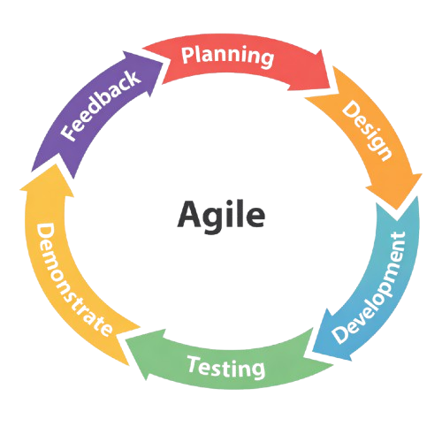
System Development Phases
Planning
In the Planning Phase, we gathered information from fish farm owners and staff through interviews and discussions to understand the daily operations of the hito farm. We identified the important processes that needed to be recorded in the system such as feeding activities, feed inventory monitoring, sales transactions, and operational expenses. This phase helped us determine the main features of the system and organize them into development tasks for the first stage of the project.
Design
In the Design Phase, we transformed the gathered requirements into system designs and interface layouts. We planned the structure of the database, system workflow, and the layout of the web interface. The design focused on creating a simple and user-friendly platform that allows staff to easily record feeding logs, monitor feed inventory, manage sales orders, track expenses, and view analytics and reports.
Development
During the Development Phase, we implemented the planned features and converted the system design into a functional web-based platform. We developed the core modules of the system including the Feeding Log, Feed Inventory Monitoring, Sales and Order Management, Expense Tracking, and Analytics and Reports. Each module was built to support the daily operations of the hito farm and ensure that data is properly recorded and organized.
Testing
In the Testing Phase, we conducted several tests to ensure that the system functions properly and meets the intended requirements. We tested the functionality of each module to confirm that feeding records correctly update the feed inventory and that sales and expenses are properly stored in the system.
Demonstrate
In the Demonstrate Phase, we presented the developed system to the fish farm owner and selected users to show how the system works. We demonstrated the main features of the system including the Feeding Log, Feed Inventory Monitoring, Sales and Order Management, Expense Tracking, and Analytics and Reports.
Feedback
In the Feedback Phase, we collected comments and suggestions from the owner after the system demonstration. The feedback helped us identify areas of improvement in the system such as usability, functionality, and overall performance.
Business Model Canvas


Gantt Chart
